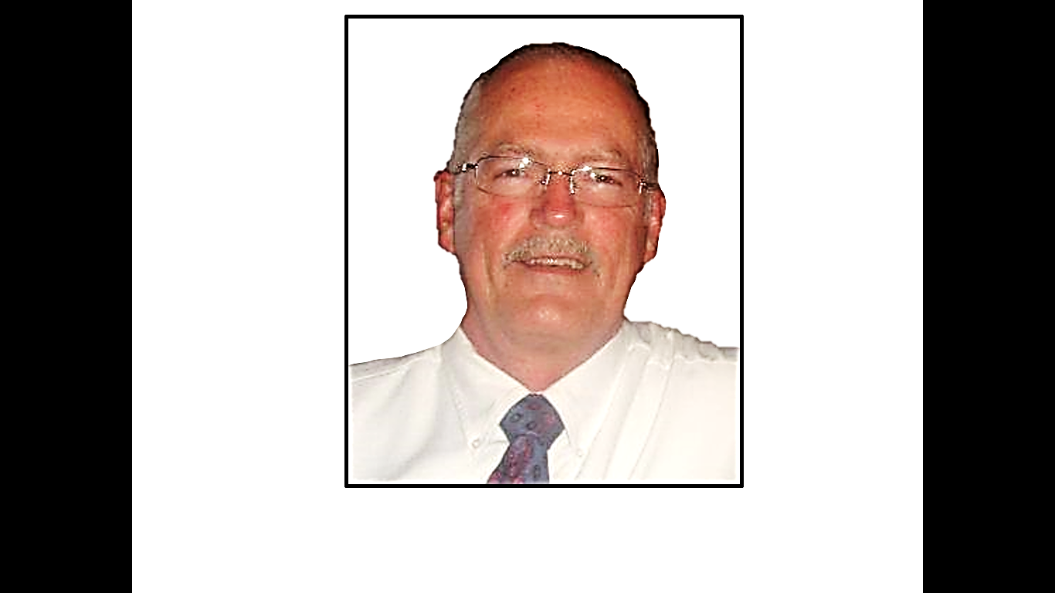



Darren Crownover is a coach and
school teacher
that is well known
and respected in the
community.
He teaches adult and
teen Bible classes.

Mike Hollingsworth is a manager
at Walmart. His
people skills are a
great asset to the
church.
He teaches adult
Bible classes.

Gary McDade is an elder and the
preacher. He also
has been a
financial planner
for over twenty
years. He has a
B.A. in Bible from
Freed Hardeman
University and a M.A.
from Amridge
University.

LET US PRESENT
A Home Bible Study
In Your Living Room
of the five lesson
Visualized
Bible Study Films

Phone: 423-800-2858
OUR
ELDERS
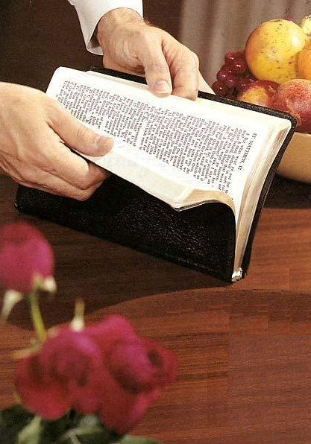

The Gospel Plan
Of Salvation

HEAR the Gospel
Romans 10:17
BELIEVE the Gospel
John 3:16
REPENT of Sins
Luke 13:3
CONFESS Christ
Romans 10:9-10
Be BAPTIZED
Acts 2:38

LIVE FAITHFULLY

