TIFTONIA
CHURCH OF CHRIST
is the home of
THE EVERLASTING GOSPEL
television program.

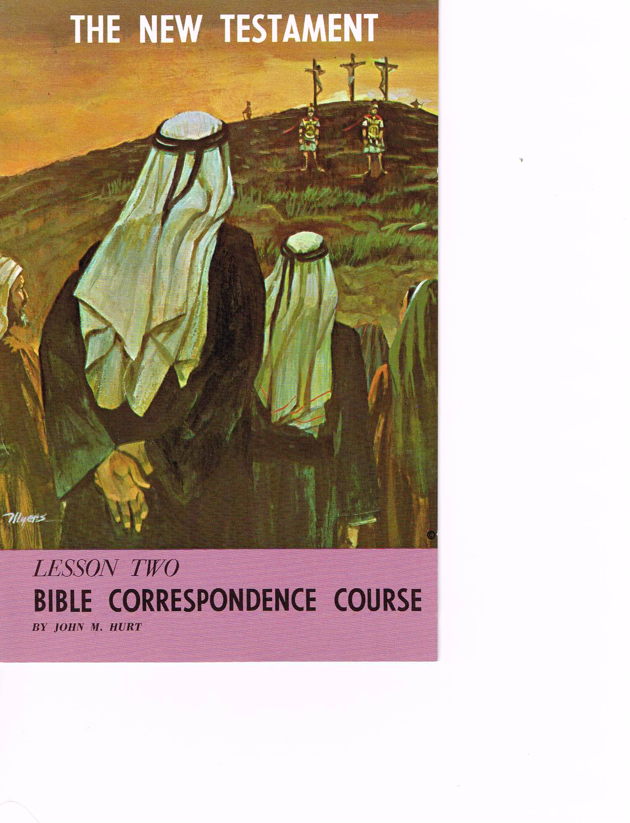
WORSHIP
WITH US
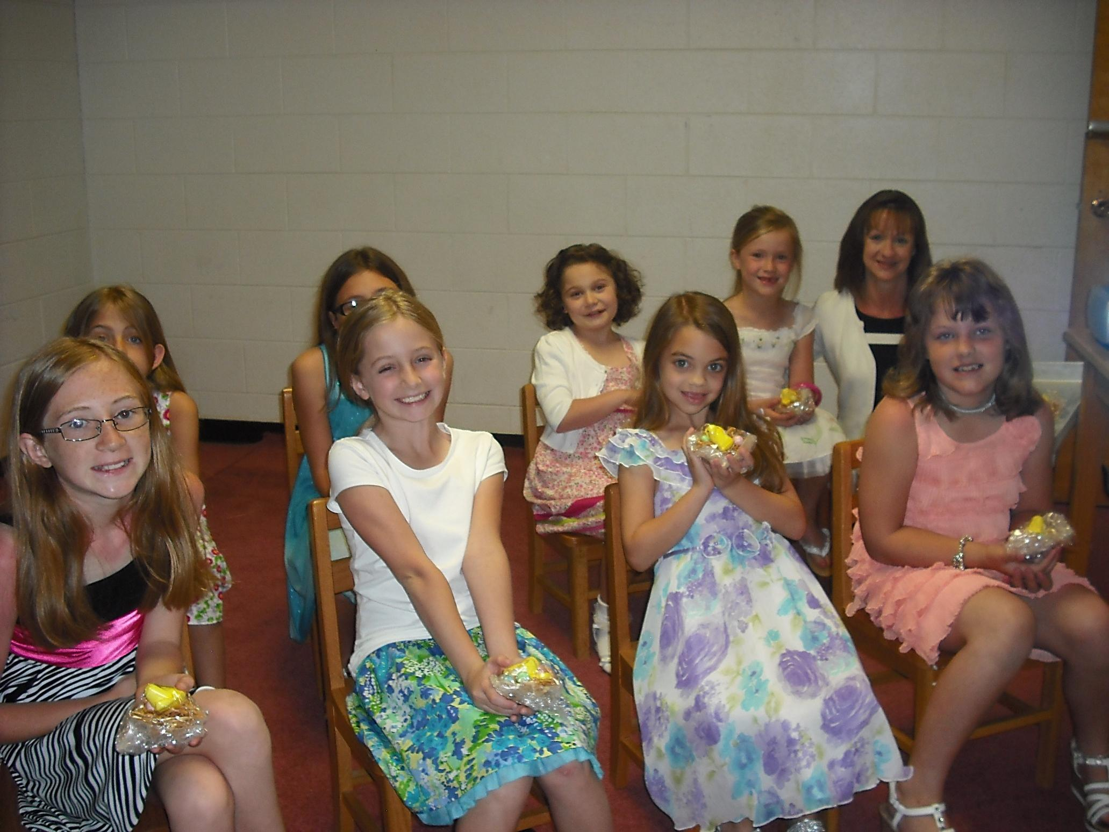
SERVICE TIMES
SUNDAY
Bible Class es 10:00 a.m.
Morning Worship 11:00 a.m.
Evening Worship 6:00 p.m.

WEDNESDAY
Bible Classes 7:00 p.m.
Hebrews 10:25

“Not Forsaking the assembling of ourselves together. . . .”
Tiftonia
Church Of Christ
159 Brown’s Ferry Road
Chattanooga, TN 37419

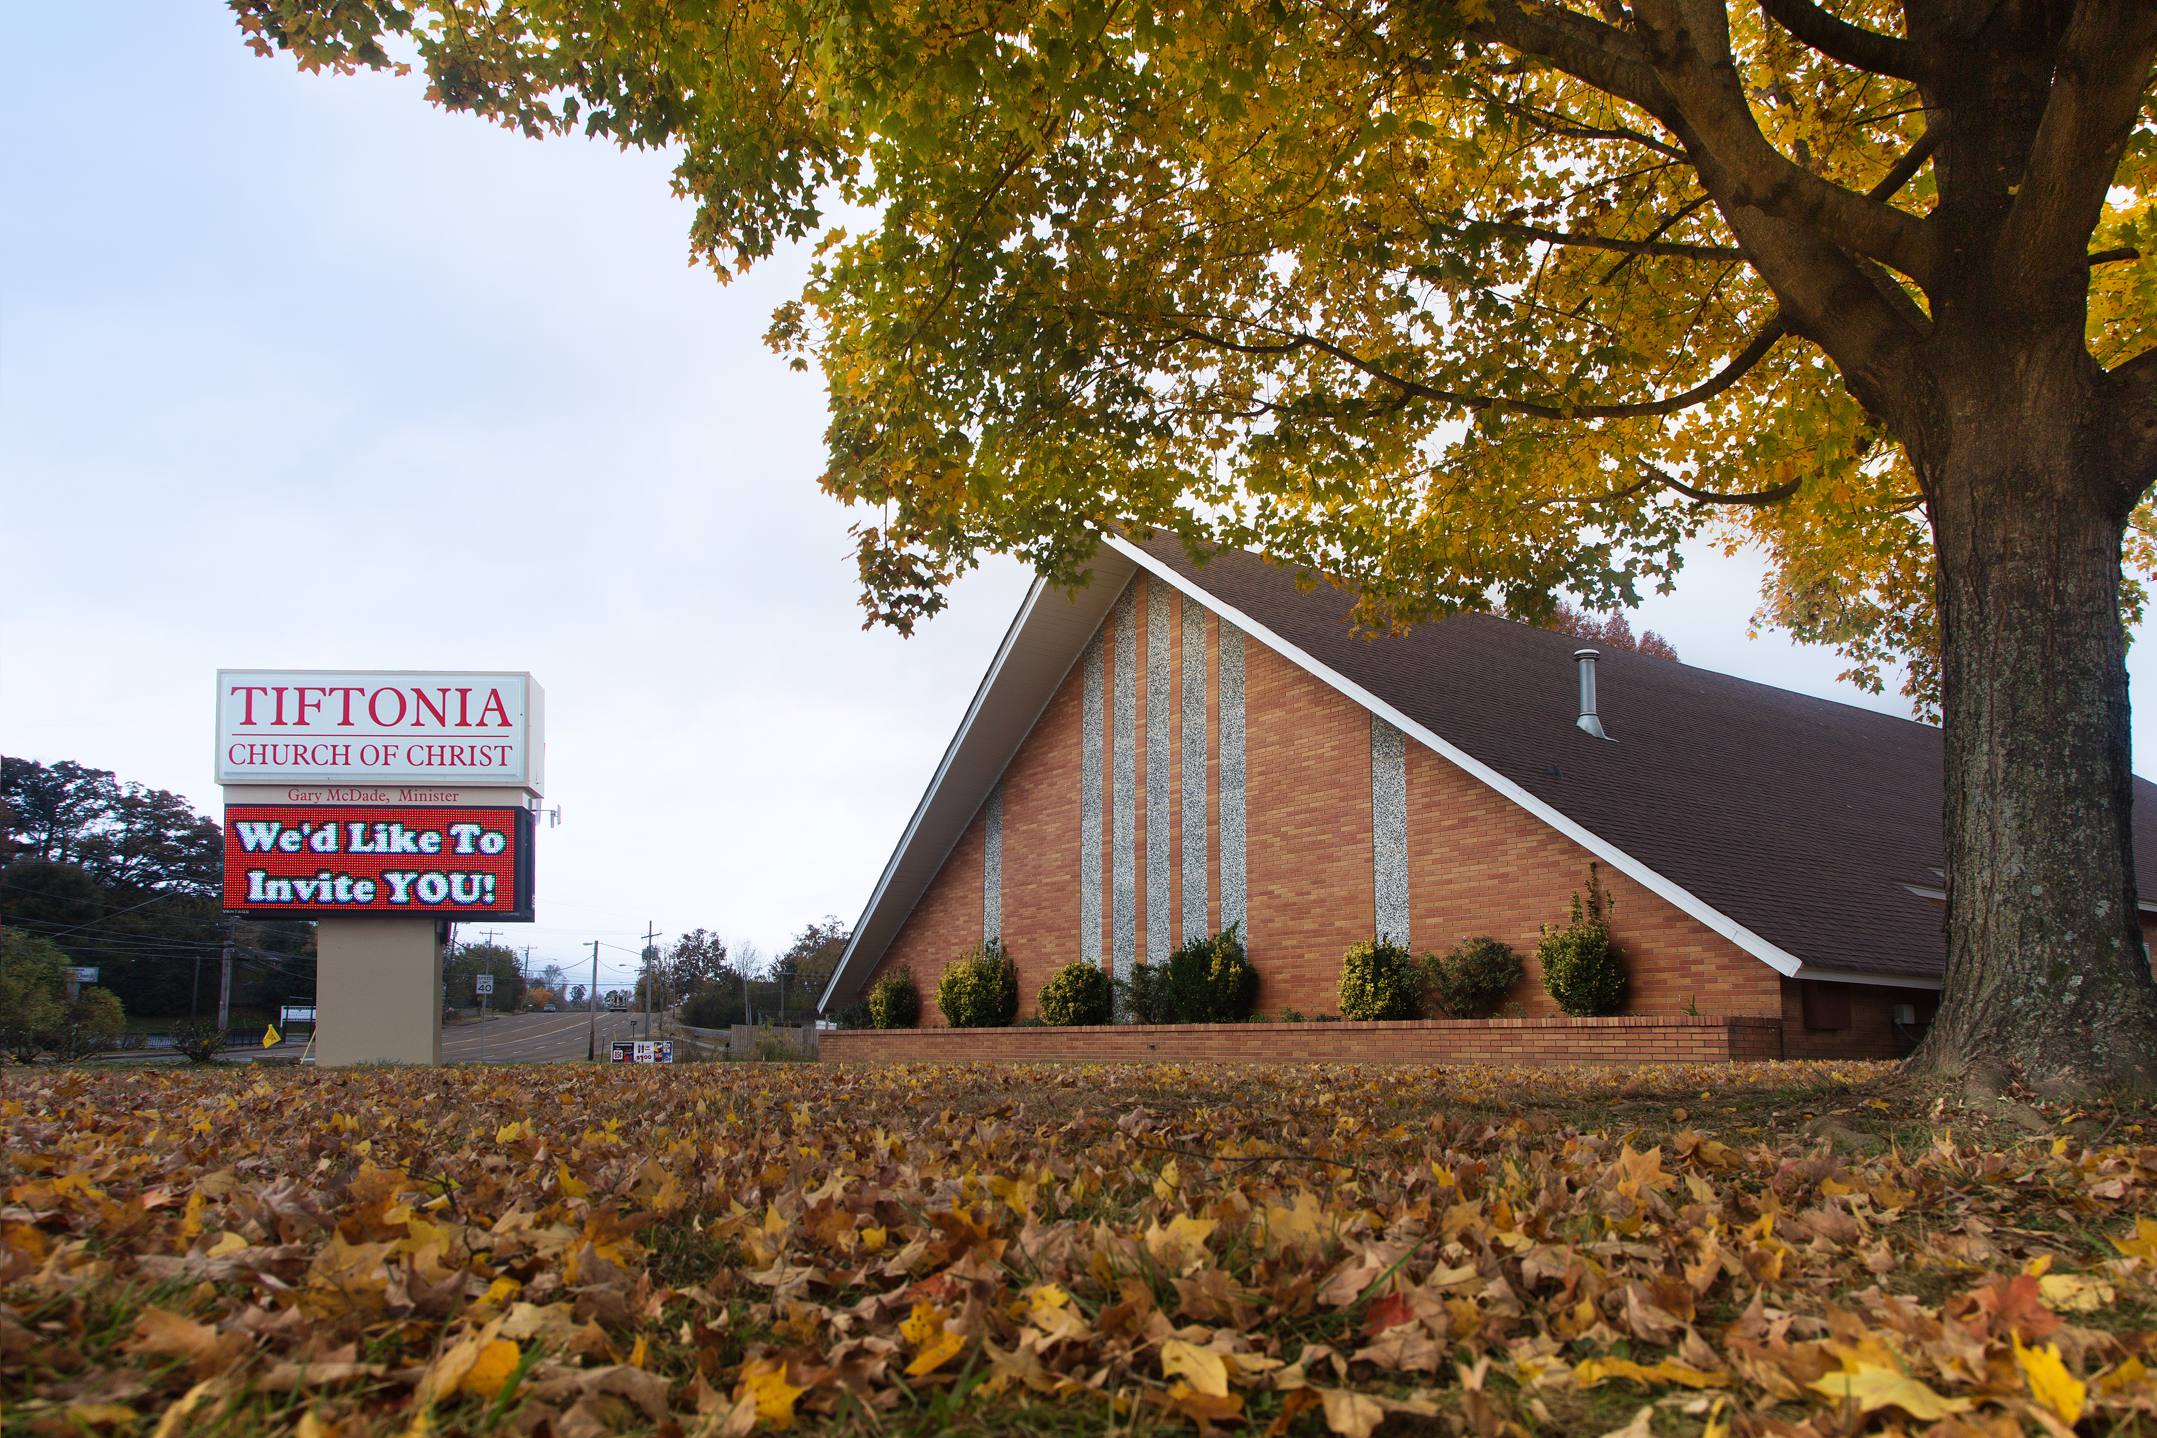

[Across from McDonalds]
Phone: 423-825-0339
Website: tiftoniachurchofChrist.com
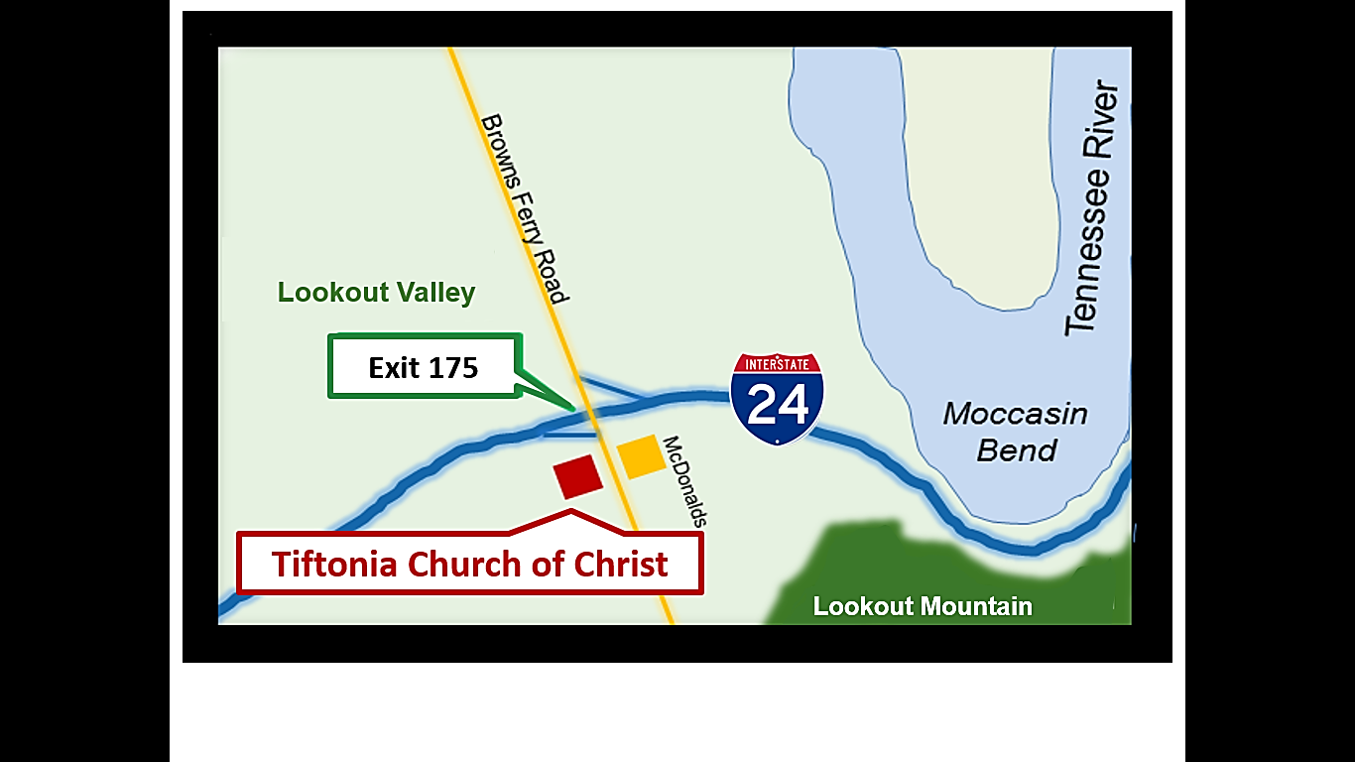
Bible Correspondence Course
By John Hurt
WE OFFER A FREE

Eight Lesson

Bible Correspondence Course

